BIT 4107 – Mobile Application Development

Lumina Studios
Professional photography and high-end videography production studio specialized in capturing visual content.
PROFESSIONAL STUDENT LOGBOOK

Student Name: | Obed Obare
Admission Number: | BIT/2025/32470
School / Faculty: | Computing and Informatics
Programme: | Bachelors in Information Tecnology
Academic Year: | Year 3
Semester: | Semester 1
Lecturer: | Mr. Michael Nyoro
Phone Number:

Platform: Android Studio | Language: Kotlin | Year: 2026

DETAILED GUIDELINES AND LOGBOOK INSTRUCTIONS
This logbook documents all weekly practical activities undertaken during the development of Lumina Studios - Professional photography and high-end videography production studio specialized in capturing visual content.
.

IMPORTANT RULES:
- Complete all sections every week without fail
- Replace every screenshot placeholder box with your ACTUAL screenshots
- Keep reflections concise — not more than 50 words per week
- Ensure screenshots clearly show your name/student number where possible
- This logbook must accompany your final project submission
- Generic AI-generated content without practical evidence will not be accepted

Every section marked [SCREENSHOT] requires a real screenshot from your own machine.

WEEK  1 | Introduction to Mobile Application Development  Project: SpareDash — Spare Parts Delivery App | Week of: _______________

Practical Activities Undertaken
During Week 1, the following activities were completed to set up the Lumina Studios development environment:
- Downloaded and installed Android Studio (latest stable version)
- Configured Android SDK: installed API 24 (min) and API 34 (target)
- Connected to an android Device (Tecno Spark 10p, Android 11)
- Installed and configured Git and linked to GitHub
- Created new Android project: Lumina Studios, package com.luminaStudio.app, Kotlin, API 24
- Verified project structure and confirmed Gradle sync completed successfully
- Explored the Mobile Application Ecosystem: Android vs iOS vs Cross-platform

Screenshots / Evidence
[ SCREENSHOT: Android Studio Welcome Screen / Installation Complete ]
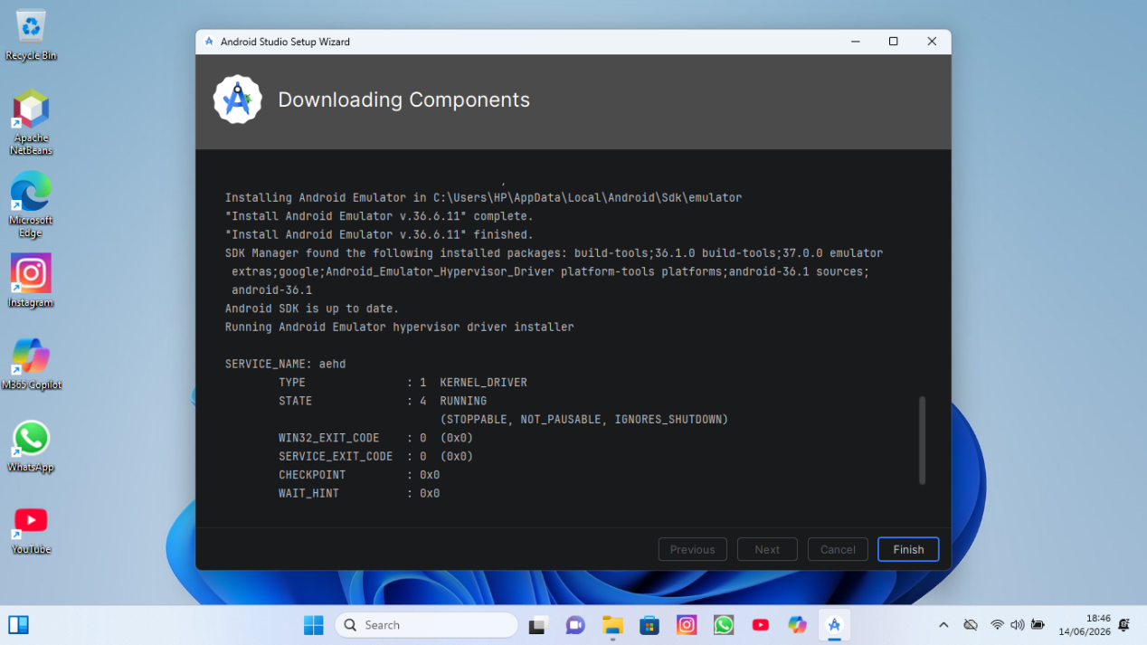

[ SCREENSHOT: Android SDK Manager showing API 24 and API 34 installed ]
Paste your actual screenshot here

[ SCREENSHOT: Android paired Device showing Tecno spark 10p connected ]
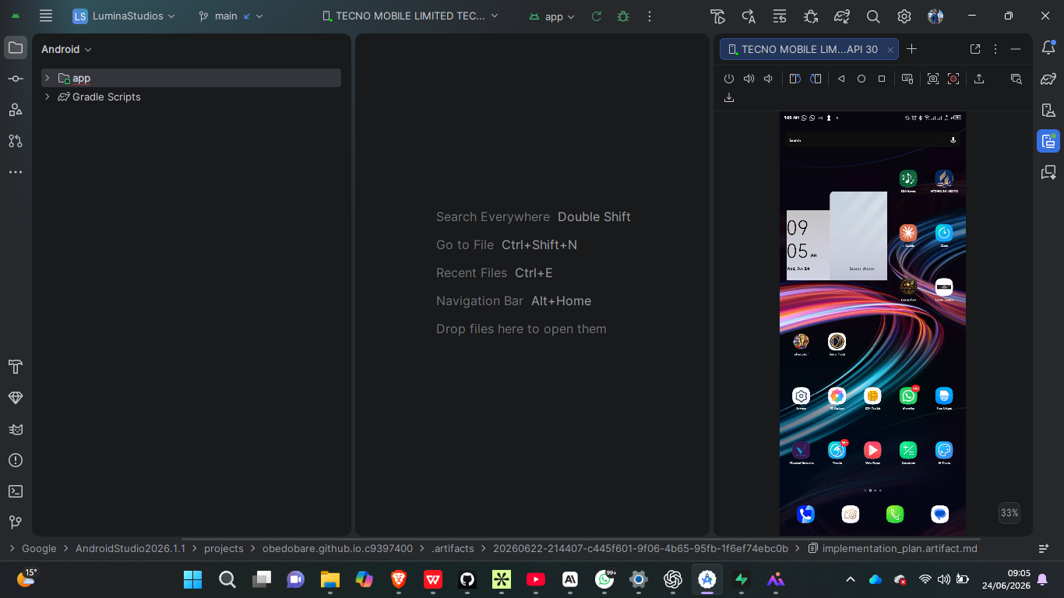

[ SCREENSHOT: New Lumina Studios project open in Android Studio showing project structure ]
t 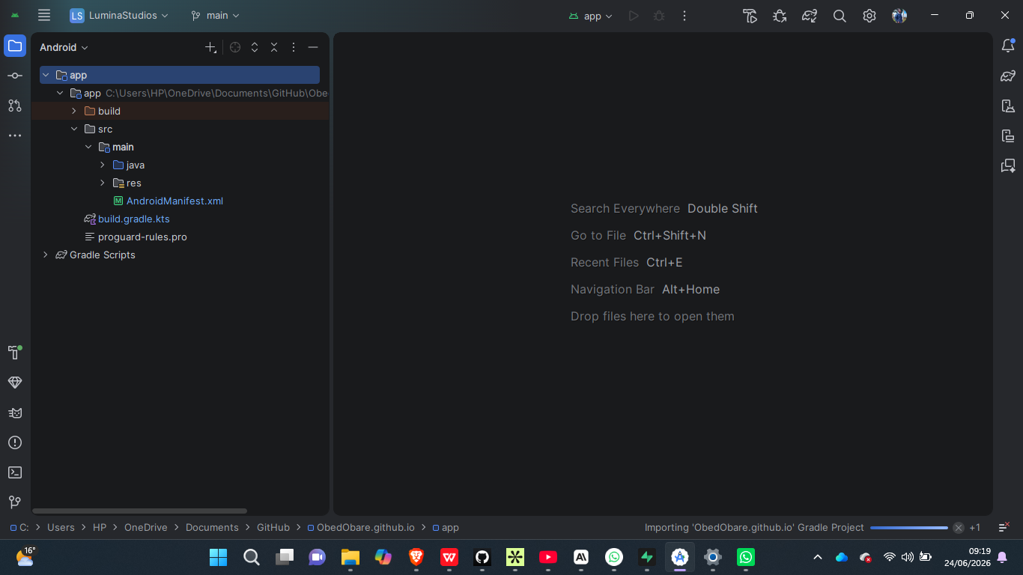

[ SCREENSHOT: Gradle sync finished message at the bottom of Android Studio ]
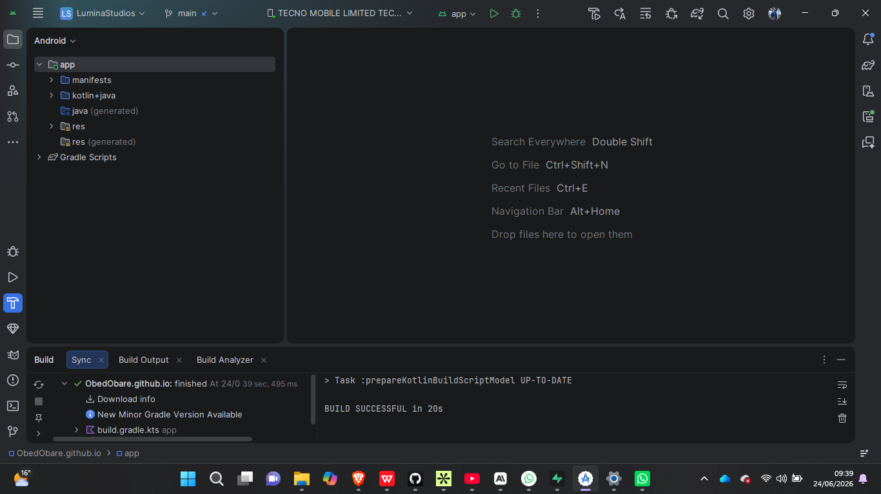

Tool / Software | Version / Details | Purpose
Android Studio | Latest Stable 2024+ | Primary IDE for development
Android SDK | API 24 + API 34 | Android platform libraries
Kotlin | Built into Android Studio | Programming language
Git | Latest | Version control
GitHub | github.com | Remote repository hosting
Java JDK | JDK 17 (bundled) | Required for Android build

Personal Reflection
Setting up Android Studio was straightforward. The most challenging part was configuring the Android SDK and ensuring the Android device ran without performance issues. The emulator brought about complications so I opted to go for an existing devive. I’ve learnt the differences between native and cross-platform development approaches. Lumina Studios will be built natively for Android using Kotlin for best performance.

